# Portfolio Optimization Project

## Introduction

The aim of this project is to develop a Monte Carlo simulation to visualize the risk return distribution of a portfolio of diverse high market capitalisation stocks from different sectors. The outcome hopes to advise an investor in this portfolio of the optimal weightings to invest into each individual security based on their risk tolerance.

## Methodology

The core of this project involves several key steps:

**1.** **Data Acquisition**: Historical adjusted closing prices for a selection of stocks across different sectors are downloaded using the yfinance library.

**2. Data Preprocessing**: Daily logarithmic returns are calculated from the adjusted closing prices. Logarithmic return was selected due to its consideration of compounding.

**3. Descriptive Statistics and Visualization**: Various plots are generated to visualize the raw stock data. The visualizations I’ve included are histogram distributions of daily return, annualized return and annualized standard deviation. These plots will be used as a reference to justify the results of the optimizations.

**4. Monte Carlo Simulation for Portfolio Generation**: Many random portfolios (10,000 in this case) are generated. For each portfolio, random weights are assigned to the selected stocks and then normalized so their sum equals 1. For each weighting the volatility and expected return are computed and stored for later plotting.

**5. Optimization**: The project employs scipy.minimize to find the portfolio that yields the maximum Sharpe Ratio and minimum Volatility. Constraints are applied to ensure that individual stock weights are within a specified range (0 to 0.25 in this case), with the upper bound preventing over concentration in any single asset and the lower bound preventing shorting.

**6. Efficient Frontier**: The efficient frontier was also plotted. The efficient frontier gives the maximum expected return for a given expected volatility. This is done by applying an additional equality constraint which fixes the expected return and then scipy.minimize is used to minimize for volatility.

**7. Capital Allocation Line CAL:** A capital Allocation Line was developed by producing an artificial spline through the efficient frontier and then developing a system of equations which are the mathematical conditions for the CAL. The system of equations is then solved to find the point on the spline that the CAL is tangent to the efficient frontier

**8. Results Visualization:** The simulated portfolios and the optimized portfolio are plotted on a mean variance graph, which visually represents the trade-off between risk and return.

**9. Portfolio Selection**: A comparative bar chart illustrates the asset weightings of the optimized portfolios. A summary table is also provided, detailing key portfolio characteristics, including expected return, volatility, and Sharpe ratio. Investment recommendations are formulated based on the investor’s risk tolerance, aligning portfolio selection with individual risk-return preferences.

## Stock Selection

These stocks were chosen based on their maturity, substantial market capitalizations, and representation across diverse sectors, ensuring diversification within the portfolio:

**Apple (Technology):**  
Launched the Apple Vision Pro in 2024; expanded investment in AI, custom silicon, and services. Subject to ongoing antitrust investigations in the U.S. and EU.

**Johnson & Johnson (Healthcare):**  
Completed the spin-off of consumer health division Kenvue in 2023. Continued litigation over talc products. Focused on pharmaceutical and med-tech growth.

**JPMorgan Chase (Financials):**  
Acquired First Republic Bank in May 2023. Benefited from high interest rates via net interest income. Continued capital returns through dividends and buybacks.

**Exxon Mobil (Energy):**  
Acquired Pioneer Natural Resources in 2024. Expanded operations in the Permian Basin. Continued investment in carbon capture and low-carbon technologies.

**Tesla (Consumer Discretionary):**  
Launched the Cybertruck in late 2024. Increased production at Texas and Berlin factories. Advanced development of autonomous driving and AI infrastructure (Dojo).

**Union Pacific (Industrials):**  
Appointed Jim Vena as CEO in 2023. Focused on operational efficiency and cost reduction following activist investor involvement.

## Methodology Limitations

Figure 1: Histograms Showing the Distribution of the Securities Daily Returns

It is important to first note the limitations of this type of portfolio analysis. For starters, return variance evaluation assumes both operational efficiency (e.g., low transaction costs) and informational efficiency. It also assumes that all returns are normally distributed however, as seen in securities like Tesla, this is clearly not the case. Another critical assumption is that historical returns can reliably predict future market performance, which may not hold true, especially in volatile or rapidly changing markets with impacts from tariffs.

## Stock Visualization

Figure 2: Daily Close Price Over the Historical Period

Figure 3: Daily Mean ROR for the Securities

Figure 4: Daily Standard Deviation for the Securities

From the above plots TSLA clearly dominates in both mean daily returns and volatility, making it the highest risk–highest return asset in the group. This is further supported by its sharp price swings and pronounced upward spike in late 2024. In contrast, JNJ shows both the lowest return and the lowest volatility, indicating a more defensive profile. JPM also stands out with relatively high returns and moderate risk, potentially offering a better risk-adjusted return than TSLA. It can be seen from Figure 4 that besides from Tesla the volatility of the stocks is relatively similar so It would be expected that the relative mean ROR of the different securities will follow a similar pattern to the weighting allocation.

## Efficient frontier plot

$$Sharpe Ratio=\frac{Expected Return-Risk Free Rate}{Expected Volatility}$$

Equation 1

## 

Figure 5 Efficient Frontier Plot with Optimal Portfolios

The plot above illustrates the results of several portfolio simulations. The cloud of circular markers represents the outcomes of a Monte Carlo simulation, where each dot corresponds to a portfolio with a randomly generated set of asset weights. The purpose of this visualization is to highlight the importance of proper portfolio weighting in achieving an optimal risk-return trade-off.

Notably, for any given level of expected return, there is a wide range of associated volatilities emphasizing the need to select portfolios that lie toward the upper-left boundary of the distribution. These portfolios offer the highest return for a given level of risk and are considered more efficient.

Another key insight from the plot is that the individual securities generally offer lower expected returns for a given level of risk compared to the overall portfolio. This highlights the value of diversification. By combining assets that do not move perfectly in sync, losses in one security can be offset by gains in another, reducing overall volatility without sacrificing returns. Diversification also helps cushion the impact of short-term fluctuations in individual asset performance. To achieve effective diversification, it is essential that the assets are not perfectly correlated. This is why, when constructing the portfolio, I selected securities from different industries, increasing the likelihood that their price movements vary in response to market conditions.

Another feature of this plot is the efficient frontier denoted by the blue line. This line represents the maximum possible expected return for a given expected volatility. This line was developed to both visualise the optimal portfolios but to also generate the tangential Capital Allocation Line. The CAL intersects the y axis at the risk-free rate (expected return from a investment with zero default risk). The gradient with this line is the Sharpe ratio and its point of tangent with the efficient frontier is the portfolio optimized for Sharpe ratio denoted by the blue start. As can be seen from Figure 5 there is another optimization for maximum Sharpe denoted by the gold start. The difference between the two optimizations is that the tangent portfolio has no constraint on the weighting applied to any asset whereas the max Sharpe optimization limited the maximum weighting to any asset to 50% of the portfolio’s investment. (Note both optimizations do not allow for a negative weighting or shorting.) The final optimization to note is the minimum volatility portfolio. This portfolio has the greatest risk aversion but offers modest returns as a result.

## Optimal Portfolios

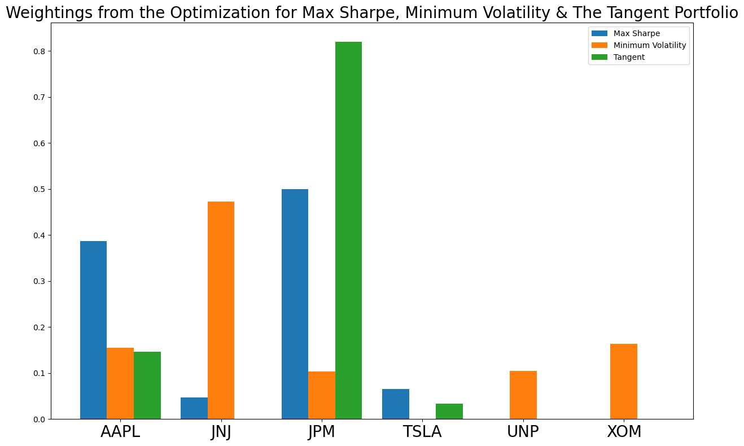

Figure 6: The Recommended Portfolio Weighting for Each Optimal Portfolio

This bar chart presents the asset weightings from the three optimised portfolios: Max Sharpe, Minimum Volatility, and the Tangent portfolio. It provides a visual breakdown of how each portfolio distributes its capital across the six selected securities, further illustrating the outcome of their respective optimisation criteria.

The Tangent portfolio, shown in green, places a heavy emphasis on JPM, assigning it over 80% of the total allocation. This reflects the fact that under no weighting constraints, the optimisation for maximum Sharpe ratio via the Capital Allocation Line tangency condition has concentrated exposure into the asset with the most favourable risk-return trade-off relative to the efficient frontier’s slope. In contrast, the Max Sharpe portfolio in blue applies a constraint on maximum weighting (e.g. 50%), leading to a more balanced but still return-driven allocation. Finally, the Minimum Volatility portfolio, shown in orange, spreads its capital across lower-volatility stocks such as JNJ and XOM, placing no weight on TSLA, which exhibits high volatility. This plot makes clear how the nature of the optimisation whether focused on pure Sharpe maximisation, minimum risk, or unconstrained tangency, drives drastically different portfolio compositions, even when drawn from the same set of assets.

## Recommendations

|  |  |  |  |
| --- | --- | --- | --- |
| Optimization Type | Expected Return | Expected Volatility | Sharpe |
| Tangent (unconstrained) | 0.32 | 0.22 | 1.27 |
| Max Sharpe (constrained) | 0.28 | 0.2 | 1.16 |
| Min Volatility | 0.09 | 0.13 | 0.31 |

Based on this analysis, I would recommend the constrained maximum Sharpe ratio portfolio. It delivers a strong risk-adjusted return (Sharpe = 1.16) with a well-diversified allocation across four securities. In contrast, the unconstrained tangent portfolio concentrates heavily in JPM, increasing exposure to idiosyncratic risk despite its slightly higher Sharpe ratio. The minimum volatility portfolio offers only a 9% return with a Sharpe ratio of 0.31, which is less than a third of the Max Sharpe portfolio. For a defensive investor, allocating to a government bond or other risk-free asset may be more appropriate than accepting limited return while still taking on market risk.